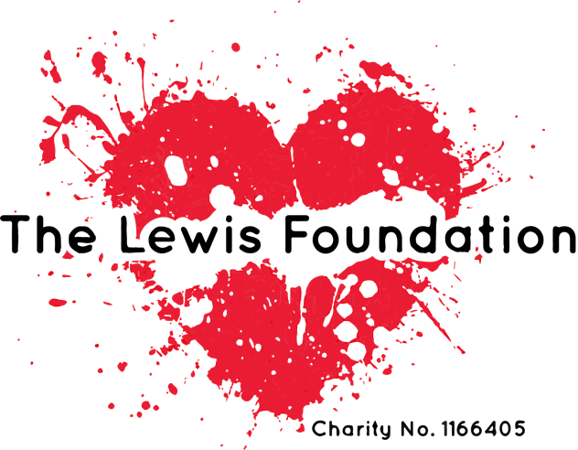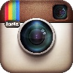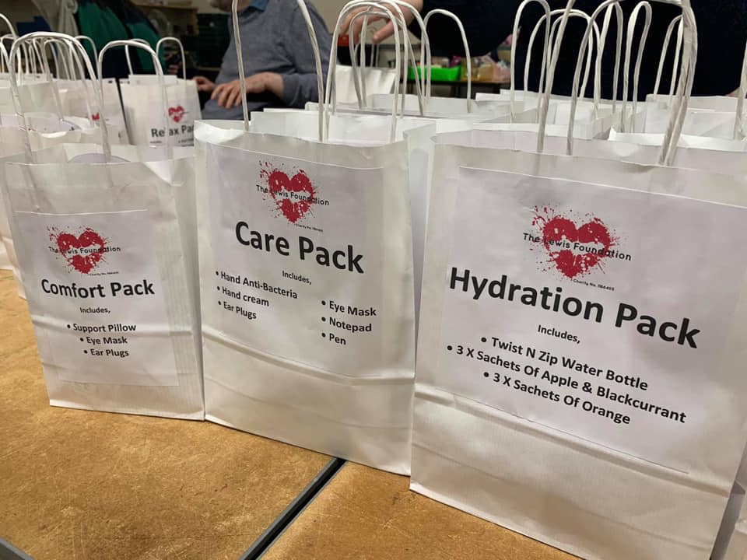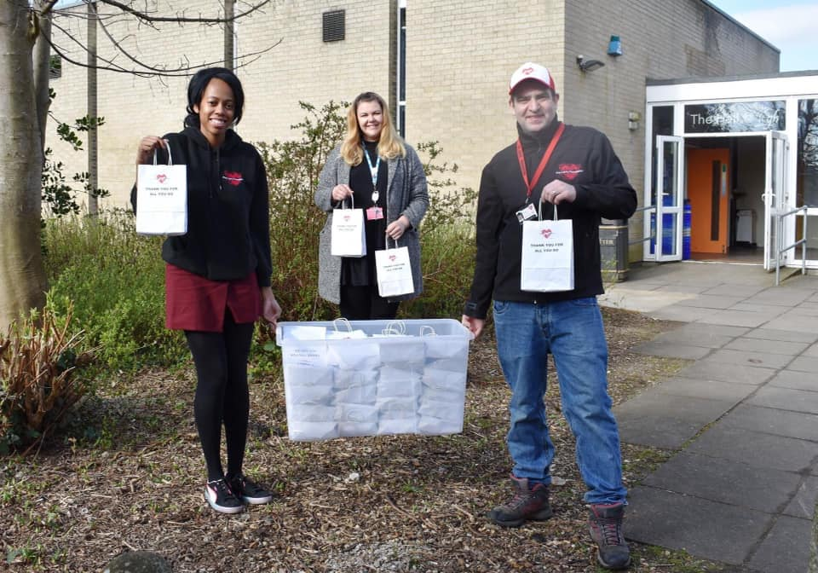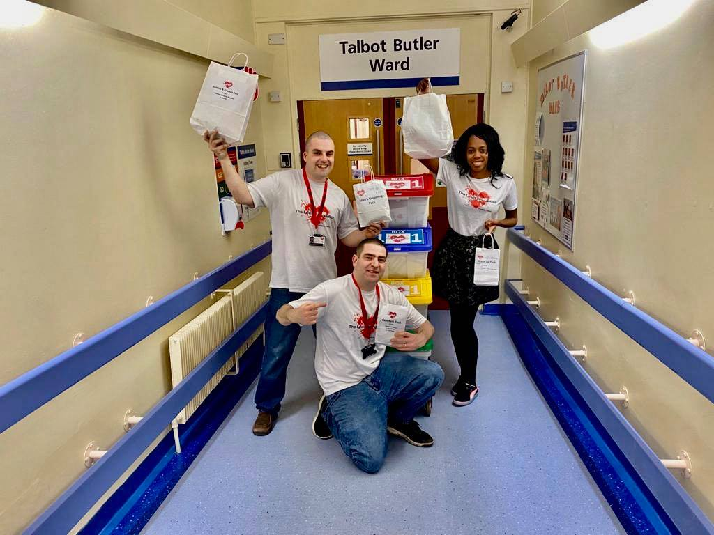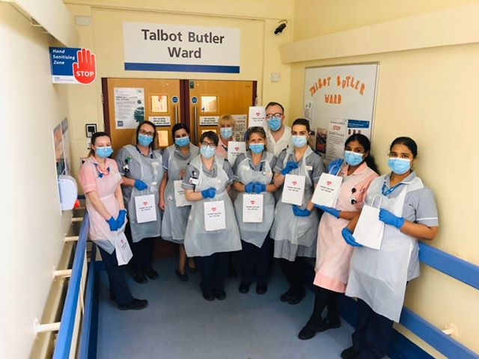

WWW.THELEWISFOUNDATION.CO.UK

The lewis foundation

thelewisfoundation

@uk_tlf

thelewisfoundationnorthampton

We provide a free gift pack to adults receiving treatment for Cancer in hospital. This is to keep people occupied during treatment and have something nice to look forward to. Items we are looking for:

* Puzzle books such as crossword, word search & sudoku.
* Travel games such as mini chess, draughts and playing cards.
* Trivia
* Cross stitch
* Knitting Kits
* Adult craft Kits
* Books
* Hand sanitiser
* Adult dot to dot books
* Adult maze Books
* Eye masks and ear plugs
* Model craft kits such as aeroplanes and cars
* Adult colouring Books
* Colouring pencils
* Sharpeners
* Letter writing sets
* Notebooks
* Pens
* Hard boiled sweets

**To donate or to support our work visit www.thelewisfoundation.co.uk/donate or open your camera on your mobile phone & scan QR code**

The Lewis Foundation Gift List