

QR CODE

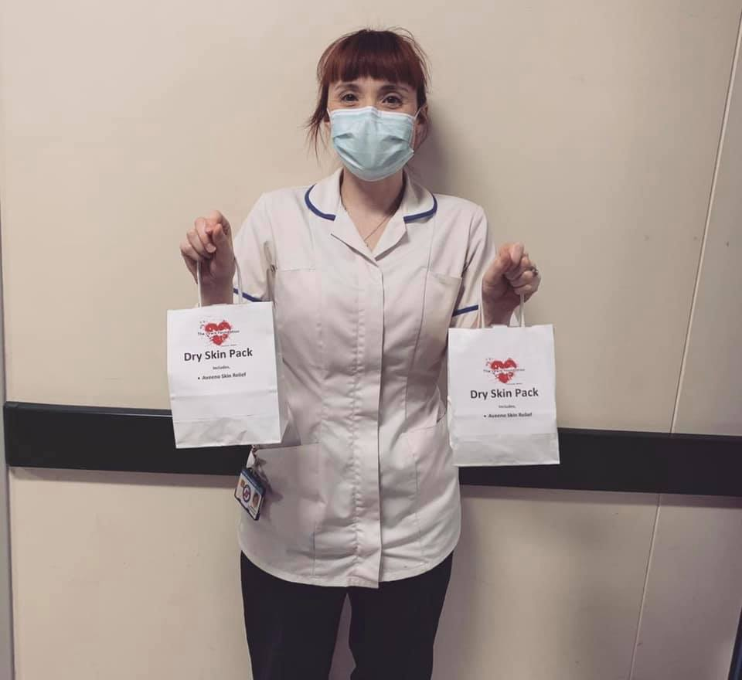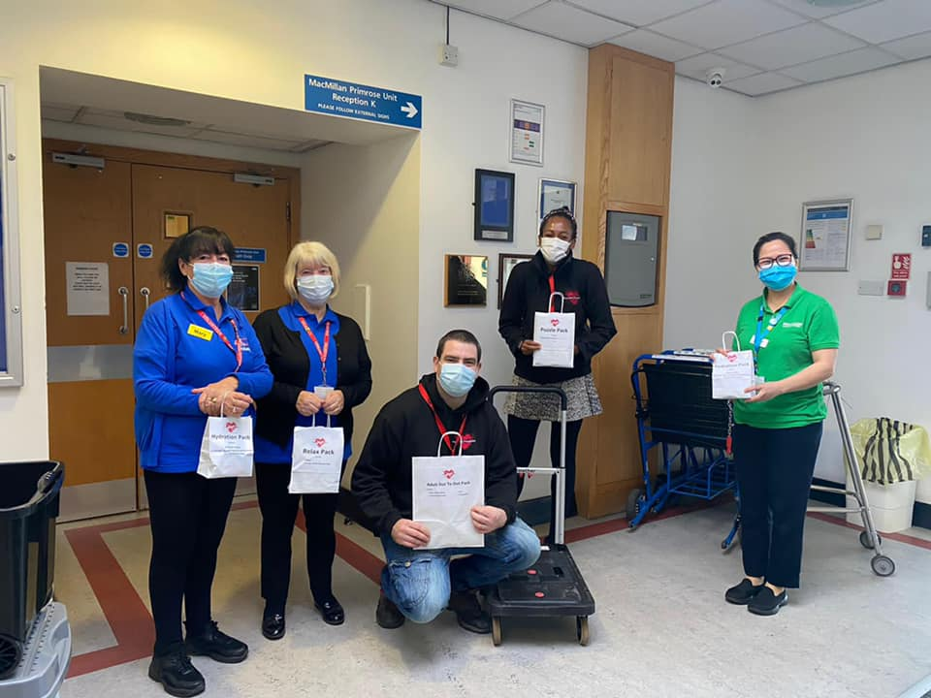

**No loose change – donate via your smartphone. Open up your camera on your mobile phone and scan QR code.**

The lewis foundation

thelewisfoundation

@uk_tlf

The Lewis Foundation

WWW.THELEWISFOUNDATION.CO.UK

Please Donate!

All money donated goes to providing free gift packs to adult cancer patients in hospital to keep people occupied during treatment.

We provide a free gift pack to adults receiving treatment for Cancer in hospital. This is so they have something nice to look forward to whilst in hospital. This could be a puzzle pack, care pack, adult colouring book pack & more. Whilst those items may not at face value seem important when you are in hospital, they become important.